# [E107]_[E108] Hop valves 1-2

At first, switch on the machine, select the service menu and open all the valves. (valves can be removed only in open position)

The hop valve No. 1 and 2 can be found at the indicated area.

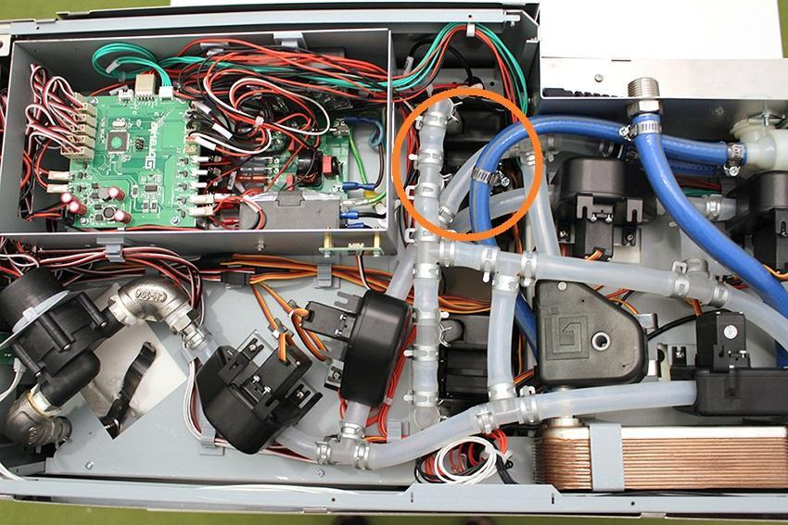

Pull off the indicated hose clamps and silicone tubes from the fittings.

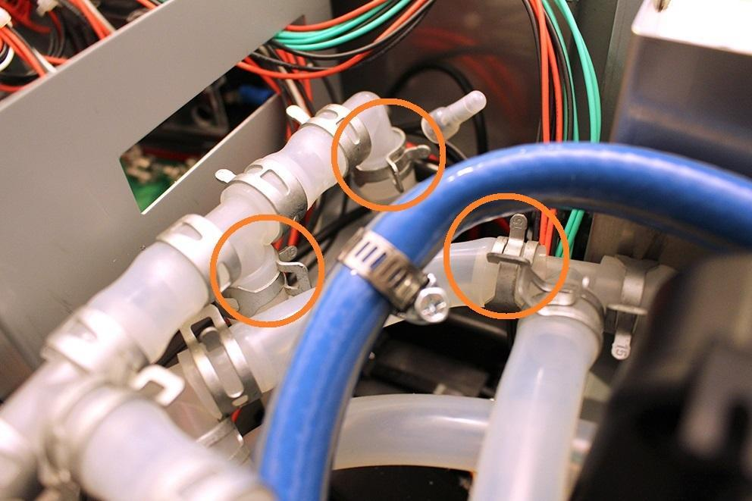

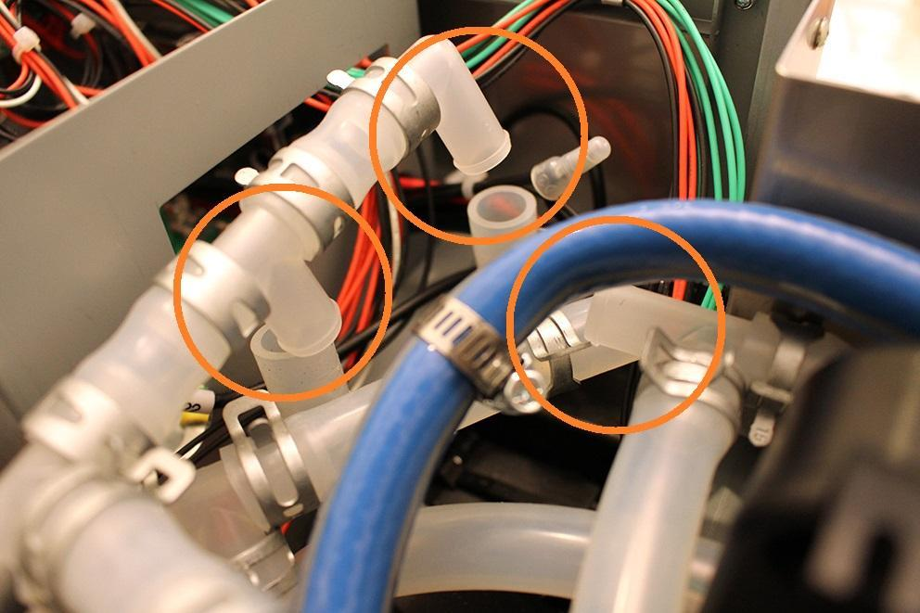

Bend the unused tubes away in order to easier assembly. Remove the hose clamps from the hop 1 and hop 2 silicone tubes.

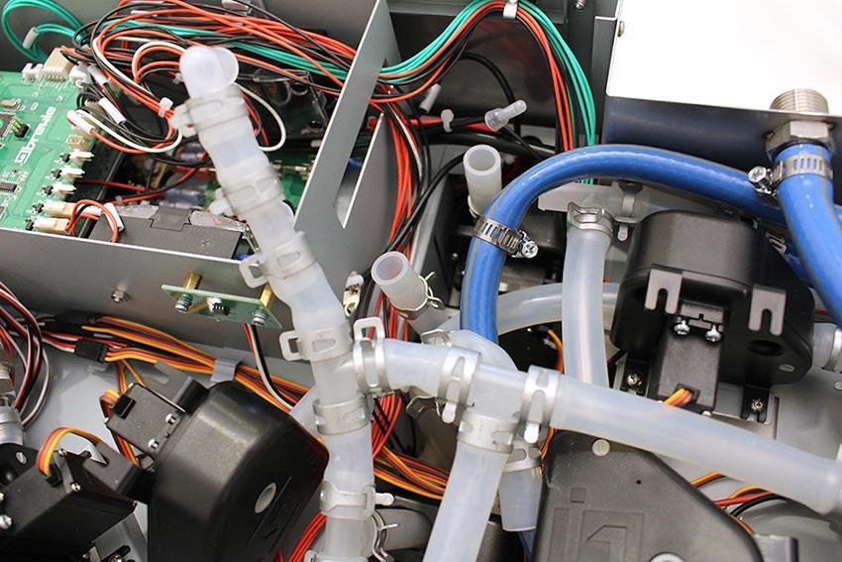

Now you can remove the hop valve 1 and 2. They are fixed together with a cable tie, so you have to cut it.

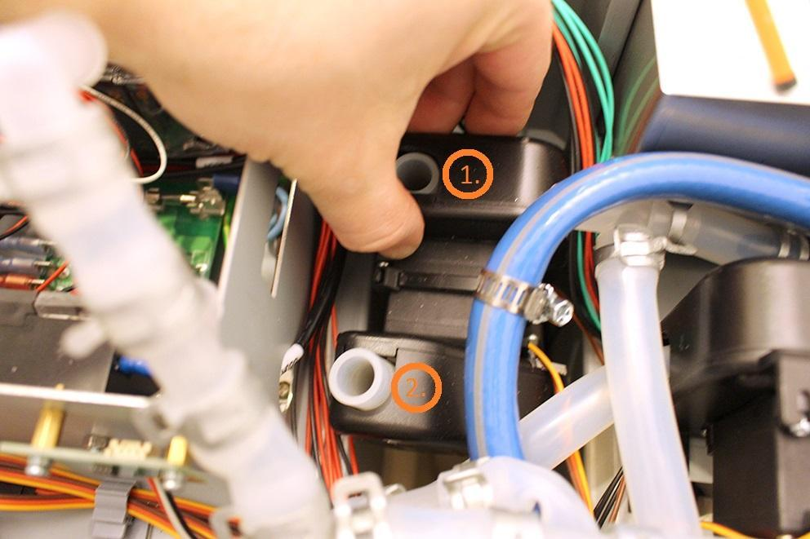

Disconnect the plug of the valve.

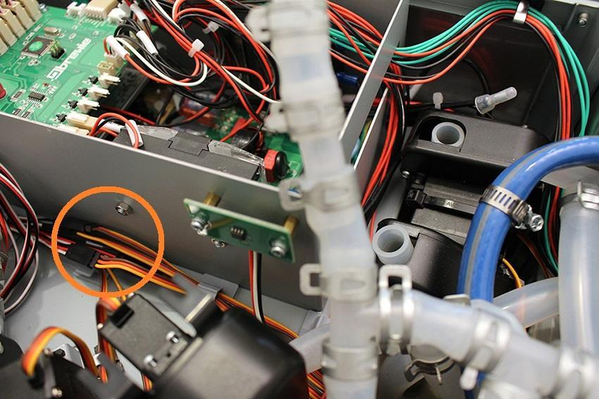

After you removed the valve, please check if the inner wall of the silicone tube is clinged together. If it is clinged together, do not change the valve, you only have to do is to separate the inner walls.

Reassemble consists of the same steps in reverse.